BÁO CÁO

2159001 - Võ Quang Dũng

2159005 - Nguyễn Huy Hoàng

2159011 - Nguyễn Ngọc Phú

2159012 - Trịnh Gia Tiến

2159020 - Nguyễn Đỗ Hải Duy

**USE CASE DIAGRAM**

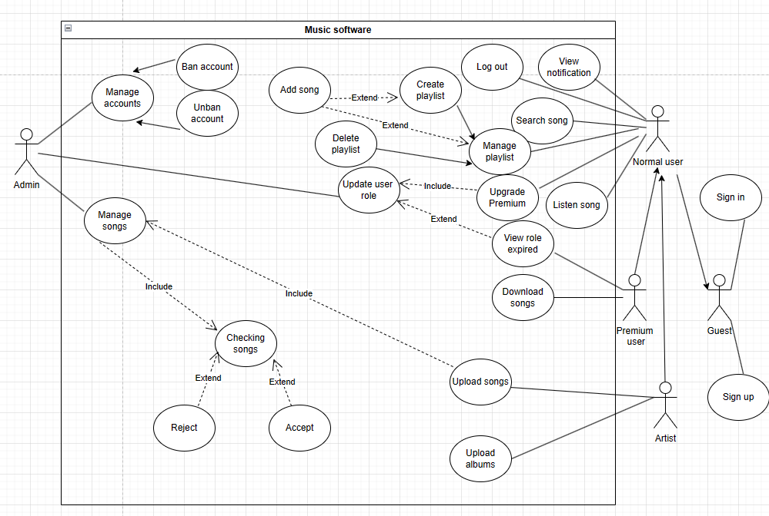

**SEQUENCE DIAGRAM**

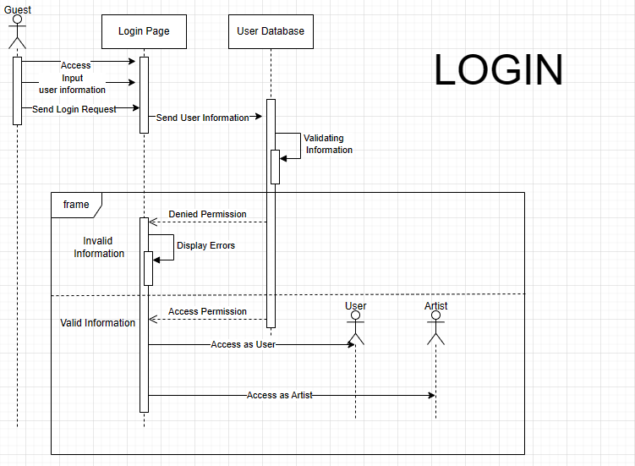

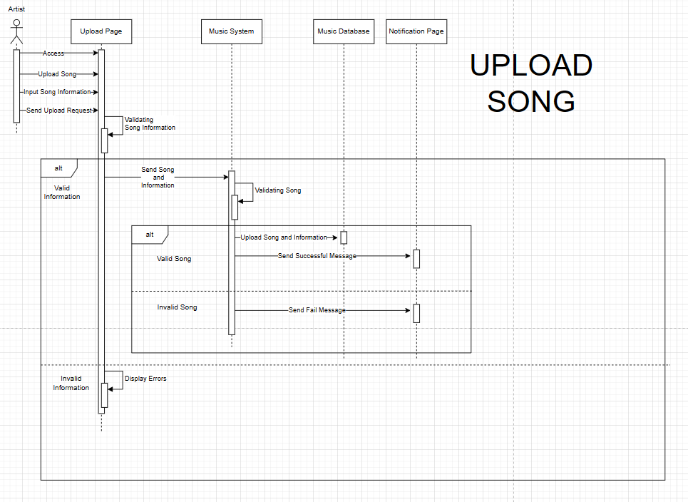

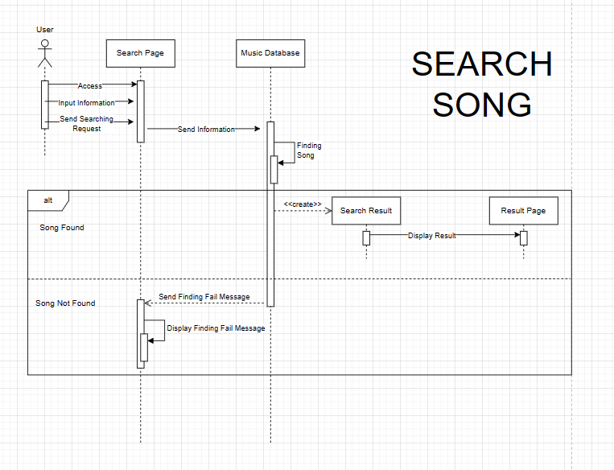

**ĐẶC TẢ USE CASE**

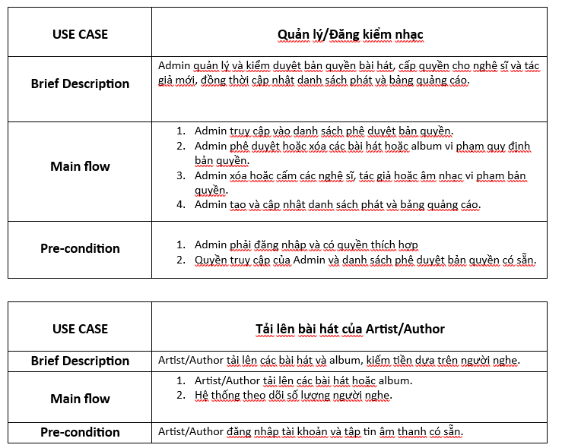

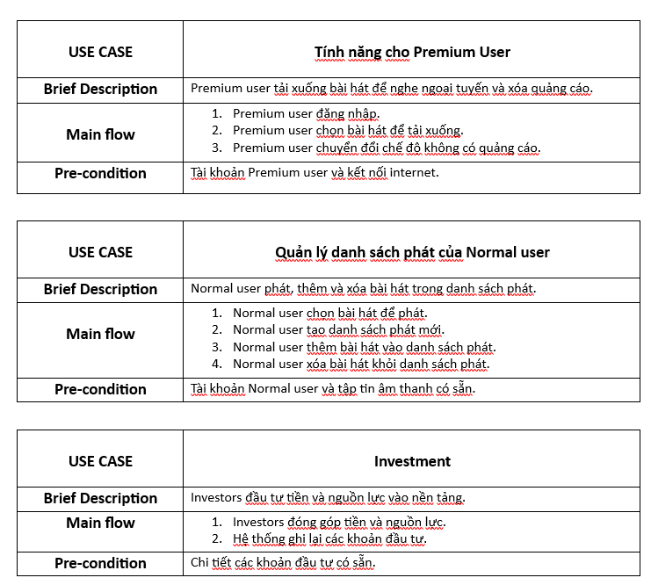

**UI**

Figma: <https://www.figma.com/file/W2rskXazWKiXg4Cv094YfE/Untitled?type=design&node-id=0-1&mode=design&t=0TSqUiUV20rRbwCC-0>

Figma jamboard: <https://www.figma.com/file/YVFP9wcFJCiZJBEPewzhRh/Mock-up-music-software?type=whiteboard&node-id=0-1&t=spyE1ye5hZi8WVM0-0>

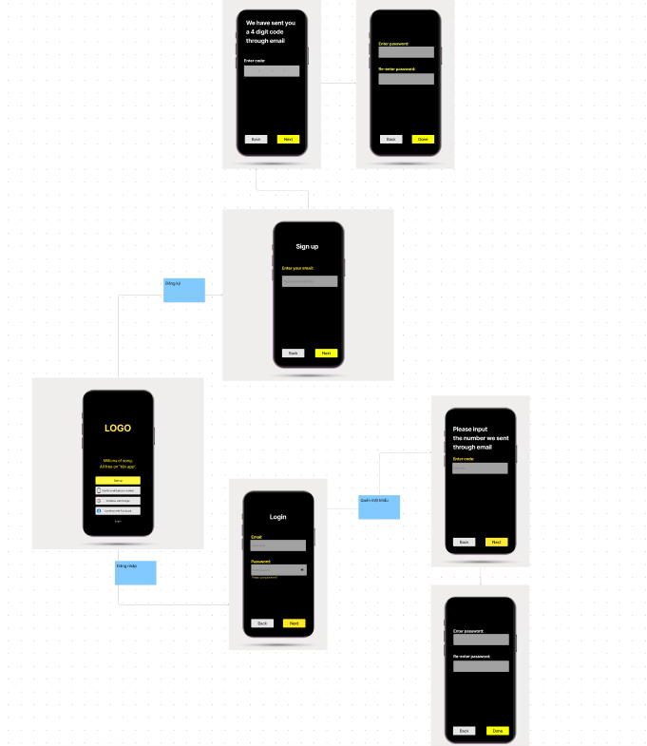

**CLASS DIAGRAM**

